**MusicPitch**



<Logo del Proyecto>

Architecture and Integration of Software Systems

Software Engineering Degree

2nd year

José Manuel Bellido Cuesta (josembell97@gmail.com)

José Antonio Carmona Fombella (joanca.carmona597@gmail.com)

José Luis Del Pino García (josedelpg@gmail.com)

Alicia Viñas Ordóñez (aliciavo97@gmail.com)

Tutor: Adela del Río Ortega

Group number: ADR-Grupo ING-MusicNess

Aplication link: http://www.music-pitch.appspot.com

Project link on projETSII, GitHub or similar: <Project link> (optional)

HISTORY OF VERSIONS

|  |  |  |  |
| --- | --- | --- | --- |
| Date | Version | Details | Participants |
| 14/03/2014 | 1.0 | - Includes an introduction, user interface mockups and UML component diagram and UML deployment diagram. | José Manuel  José Antonio  José Luís  Alicia |
|  |  | <Mention the most significant changes regarding the previous versionr> |  |
|  |  |  |  |
|  |  |  |  |
|  |  |  |  |

Index

1 Introduction 4

1.1 Integrated aplications 4

1.2 Project evolution 4

2 User interface mockups 5

2.1 View X 5

2.2 View Y 5

3 Architecture 6

3.1 Component diagram 6

3.2 Deployment diagram 7

3.3 High level sequence diagram 8

3.4 Class diagram 9

3.5 Sequence diagrams 9

4 Implementation 10

5 Testing 11

6 User guide 12

6.1 Mashup 12

6.2 API REST 12

References 13

# Introduction

Presentar y motivar el problema que se va a resolver con la aplicación. ¿Por qué es un problema importante?

Describir el mashup desarrollado y como éste le da solución al problema mencionando anteriormente. ¿Por qué es un buen mashup?

## Integrated aplications

Describir cada una de las aplicaciones integradas dando detalles sobre cada una de ellas

|  |  |
| --- | --- |
| Nombre aplicación | URL documentación API |
| Facebook | https://developers.facebook.com/docs/graph-api/using-graph-api/ |
|  |  |
|  |  |

Tabla 1. Aplicación integradas

## Project evolution

Es habitual que la aplicación final diste mucho de la idea inicial. Puede que la idea fuese muy compleja, no haya sido posible integrar alguna de las aplicaciones o alguno de los miembros del grupo haya abandonado. Explicar en esta sección cuál ha sido la evolución del proyecto, problemas, cambios, decisiones, etc.

# User interface mockups

Insertar las imágenes de todos los prototipos desarrollados. Añadir para cada prototipo una breve descripción textual. Se recomienda hacer prototipos simples y realistas. Para los prototipos pueden usarse aplicaciones como Balsamiq [1]

## View X

Descripción textual de la vista

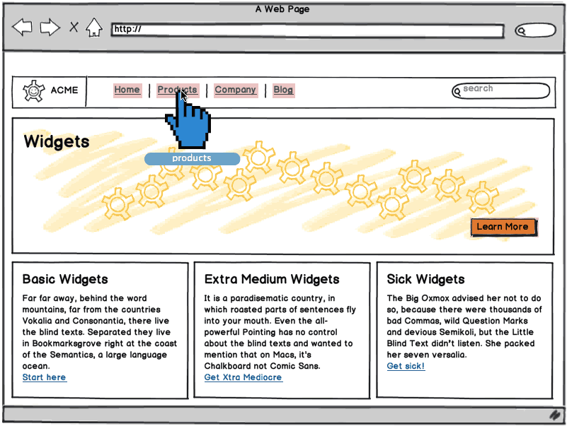

Figura 1. Prototipo de interfaz de usuario de la vista X

## View Y

# Architecture

Insertar los diagramas UML de componentes y de despliegue de la aplicación. Describir textualmente

## Component diagram

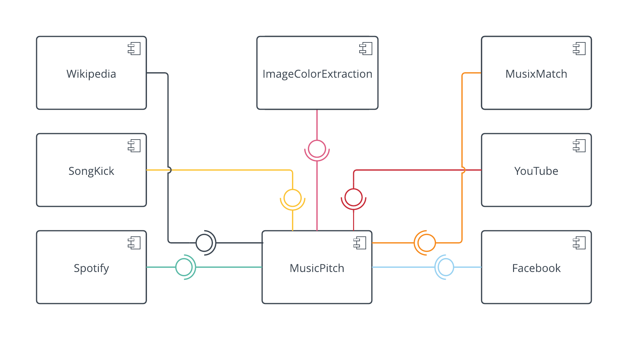High level UML component diagram. Includes the integrated aplications and our own aplication as an independent component.

This diagram shows a basic representation of our system’s logic architecture. It consists of a serie of eight component: seven of these component are applications integrated in our application, and the eighth component is our own application. These components are related by their interfaces. In our case, Wikipedia, SongKick, Spotify, ImageColorExtraction, MusixMatch, YouTube and Facebook provide their interfaces to MusicPitch.

## Deployment diagram

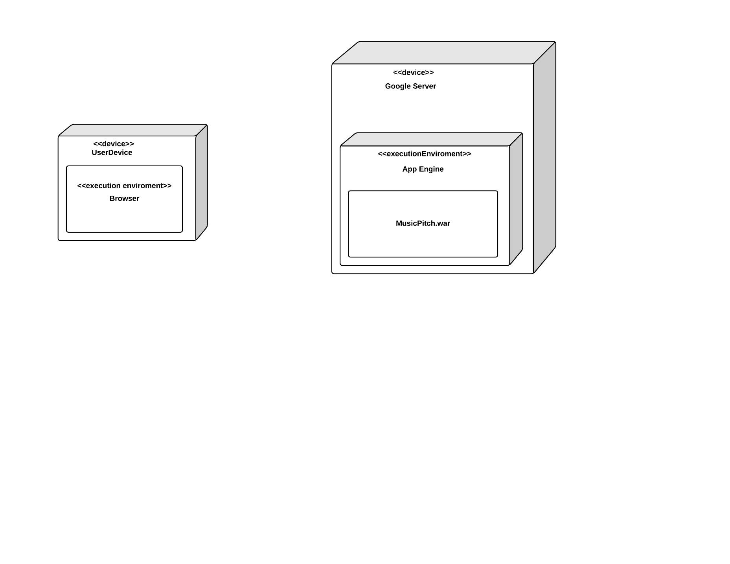UML deployment diagram of the application.

This diagram shows the physical architecture on which our software system is deployed, it describes both physical devices and software elements. It consists of an artifact and four nodes: two devices and two execution enviroments.

On the left there is the general device that the user is using (smartpgone, PC, …), a hardware node. It contains inside another node, in this case, an execution enviroment. That execution enviroment is the web browser from where the user will be able to access to our software system.

The path that link both sides is the connection being used, for example, Wi-Fi connection or Ethernet connection between both devices.

On the right there is the Google server which contains the Google AppEngine execution enviroment, and from where our system’s artifact or file is deployed.

## High level sequence diagram

UML sequence diagram which indicates the message flow between the different integrated applications.

In our case, we decided to divide the high level sequence diagram in three, so we can represent clearly and appropiately the message flow that happens according to each of the three base cases that our system allows.

SONG DIAGRAM

Firstly, this is the diagram in case that the user is interested in a song search.

The user searchs a term that will later be the parameter of three petitions from MusicPitch to Spotify in order to obtain songs, albums and artists results related to that parameter.

When the search results are shown to the user, in this first case, he or she decides to click on some song from the ones that are shown on the screen. This song will be obtained from Spotify using its ID, which was already obtained in the first general search.

Then, we make a petition to ImageColorExtraction with the choosen song’s álbum artwork, in order to obtain its primary color and use it as a background color of the web page. We also make a petition to MusixMatch in order to obtain the choosen song’s lyrics and a last petition is made to YouTube in order to obtain the video that best suits these parameters.

Furthermore, there exists two optional actions that the user can make and that would require additional messages between the applications. If he or she is interested in adding the choosen song to his or her Spotify playlist, we will need to send another petition to Spotify. Again, if what he or she wants is to share a lyrics fragment on his or her Facebook profile, a petition to Facebook will be required.

ARTIST DIAGRAM

Secondly, this is the diagram in case that the user is interested in an artist search.

The user searchs a term that will later be the parameter of three petitions from MusicPitch to Spotify in order to obtain songs, albums and artists results related to that parameter.

When the search results are shown to the user, in this second case, he or she decides to click on some artist from the ones that are shown on the screen. This artist will be obtained from Spotify using its ID, which was already obtained in the first general search.

Then, we make a petition to ImageColorExtraction with the choosen artist’s profile picture, in order to obtain the primary color and use it as a background color of the web page. A petition to Wikipedia is made with the artist name in order to obtain his or her biography, another petition is made to SongKick in order to obtain information about the artist’s latest concerts and a last petition is made to Facebook in order to obtain the choosen artist’s profile on this social network.

ALBUM DIAGRAM

Thirdly and in last place, this is the diagram in case that the user is interested in an album search.

The user searchs a term that will later be the parameter of three petitions from MusicPitch to Spotify in order to obtain songs, albums and artists results related to that parameter.

When the search results are shown to the user, in this third case, he or she decides to click on some album from the ones that are shown on the screen. This album will be obtained from Spotify using its ID, which was already obtained in the first general search.

Then, we make a petition to ImageColorExtraction with the choosen album’s artwork, in order to obtain the primary color and use it as a background color of the web page. This is the last petition needed in this case, due to the fact that all the information needed about the álbum was already obtained previously.

Furthermore, there exists an optional action that the user can make and that would require additional messages between the applications. If he or she is interested in adding the choosen album to his or her Spotify playlist, we will need to send another petition to Spotify.

## Class diagram

Diagrama UML de clases indicando la distribución de las clases entre las distintas capas, según el patrón MVC.

## Sequence diagrams

Diagramas UML de secuencia ilustrando la comunicación entre vistas, controladores y clases del modelo.

# Implementation

Describir brevemente los aspectos de la implementación que creen da más mérito al trabajo. Añadir algún fragmento de código si se considera oportuno.

# Testing

Documentar las pruebas realizadas a la aplicación. Justificar textualmente la estrategia de pruebas seguida y por qué (ej. pruebas incrementales ascendentes).

Indicar el número total de pruebas realizadas y cuáles de ellas han sido automatizadas mediante JUnit.

|  |  |
| --- | --- |
| Resumen |  |
| Número total de pruebas realizadas | 25 |
| Número de pruebas automatizadas | 20 (80%) |

|  |  |
| --- | --- |
| ID | **Prueba 1** |
| Descripción | Prueba para la detección de errores al implementar búsquedas en Spotify usando servicios RESTful. |
| Entrada | Se hace uso de la librería XXX para invocar al servicio usando la URI YYY desde nuestra aplicación. |
| Salida esperada | Los datos devueltos en formato JSON son mapeados a una clase Java y a continuación se muestran por pantalla. |
| Resultado | **EXITO** |
| Automatizada | Sí |

# User guide

## Mashup

Indique textualmente e **incluyendo capturas de pantalla** el manual de uso del mashup.

## API REST

Indique la documentación de la API REST (contrato) implementada [2]. Cómo mínimo, la API debería incluir:

1. Protocolo de aplicación empleado por el servicio.
2. URIs para invocar a las operaciones del servicio.
3. Formato empleado para las representaciones de los recursos.
4. Códigos de estado empleados por el servicio.
5. Ejemplos de uso.

Está información también debe facilitarse en formato HTML como parte de la aplicación.

# References

[1] *Balsamiq*. <http://balsamiq.com/>. Accedido en Enero 2014.

[2] J. Webber, S. Parastatidis y I. Robinson. *REST in Practice: Hypermedia and Systems Architecture.* O'Reilly Media. 2010.